First Screen

1. **DOCUMENTATION OVERVIEW**

This guide describes the screen functionalities of the Endorsement transaction. It contains

(1) breadcrumb information how to navigate to the screen, (2) navigation and workflow

steps, (3) common controls for tracker, navigation buttons, and summary information, and

(4) usage information for the basic functions of screen objects and web components,

together with their corresponding definition.

1. **SCREEN AND REPORT LIST**

* SCREEN/REPORT ID - SCR4104013
* SCREEN/REPORT NAME - Endorsement – Policy Transaction History
* DESCRIPTION - - Screen to show the policy record history and the policy record coverage to serve as a reference and guide to the end-user.

1. **SCREEN DESIGN SPECIFICATIONS**

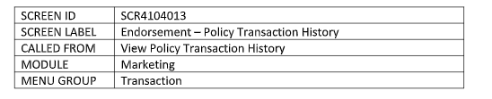

1. Policy Transaction History

-Allowing user to view the transaction history of the current policy. This contains the Policy Information, Policy Record History and Policy Record Coverage.

1. Policy Information

* The policy information is Policy Trans. No, Business Type, Status, Policy No, For the Account Of, Assured/Policy Holder, Insurer/Principal, Insurance Line/Type, Coverage Period, TSI, Branch, Business Unit, Marketing AO, Referror, Bank Branch/Department, Bank Group/Division, Business Source, Mortgagee/Obligee, and Reference No.

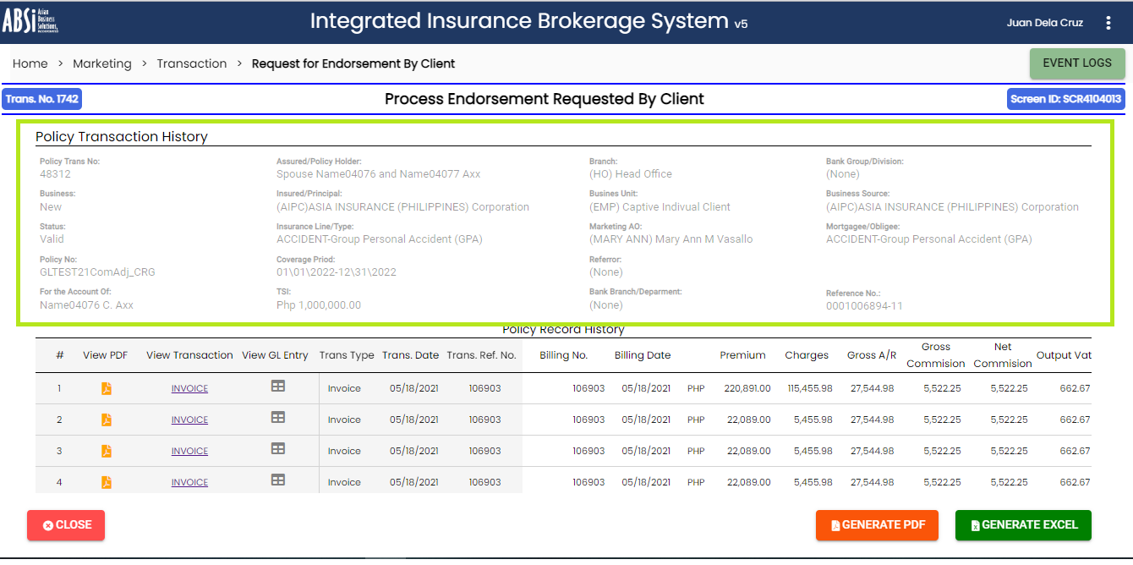

1. Policy Record History

* This shows the transaction record history of the policy (such as transaction date, transaction ref. no, Transaction ref date, transaction type, billing no., billing date, Premium, charges gross AR, gross commission, net commission, output VAT, Wtax, remittable amount, CWT, net due, discount and posted in GL flag. Allowing user to view the PDF report of the transaction, transaction screen and GL entry.

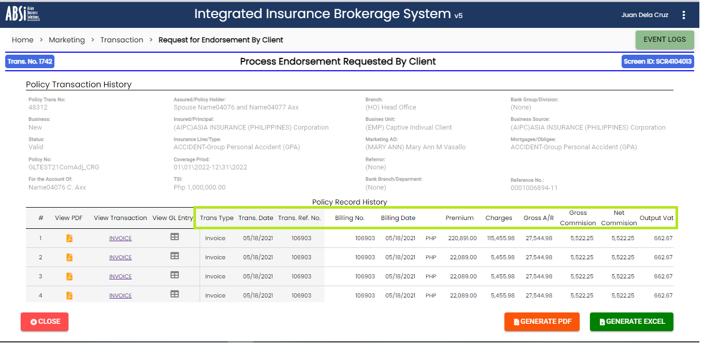

1. Policy Record Coverage

* Policy Record Coverage shows the type, coverage, coverage description, covered amount, premium amount, commission, premium rate, commission rate and remarks of Net, Policy Booking and Endorsement transaction.

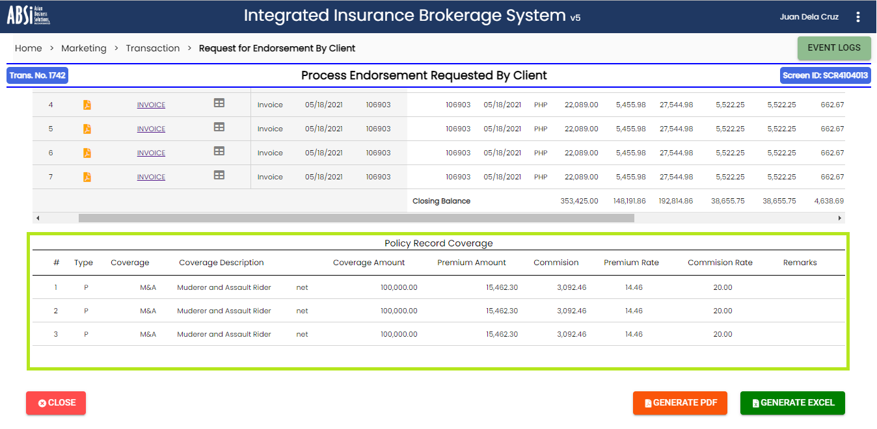

1. Generate PDF button

* Providing user a facility to generate PDF report of the policy transaction history upon clicking “Generate PDF” button. (No function)

1. Generate Excel button

* Providing user a facility to generate Excel report of the policy transaction history upon clicking “Generate Excel” button. (No function)

1. Close button

* Allowing user to close the policy transaction history screen and return back to the last screen viewed. (No function)

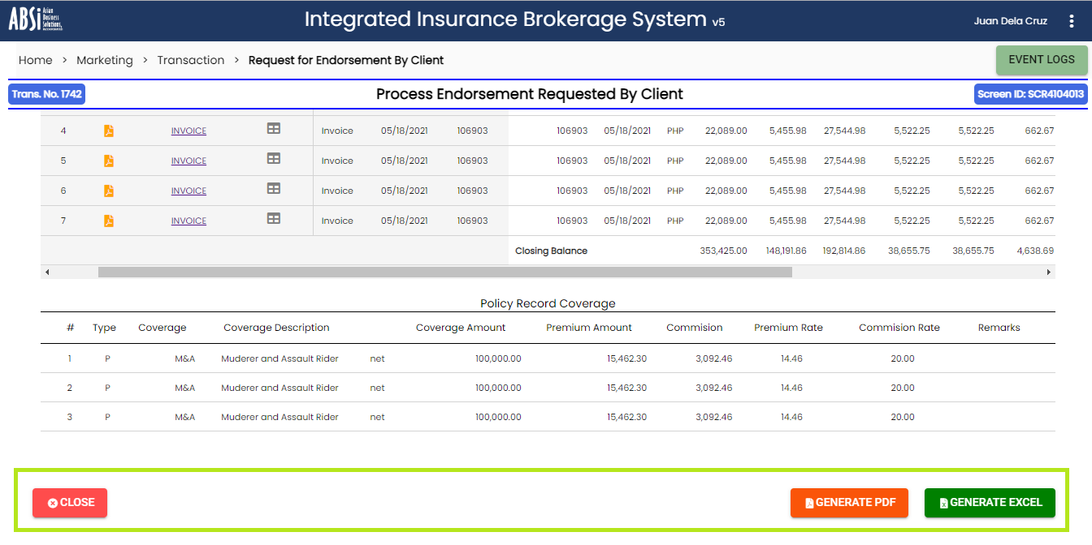

1. View PDF

* Allowing user to display the PDF report of the invoice related transaction such as Invoice, CM, Comm. Adjustments, AR, OR, Payment Adjustment, Payment Recon, Premium Remittance Voucher and VAT Voucher report. (No function)

1. View GL Entry

* Allowing user to display the GL entry of the invoice transaction. (No function)

1. View Transaction

* Allowing user to display the policy record transaction screen. (No function)

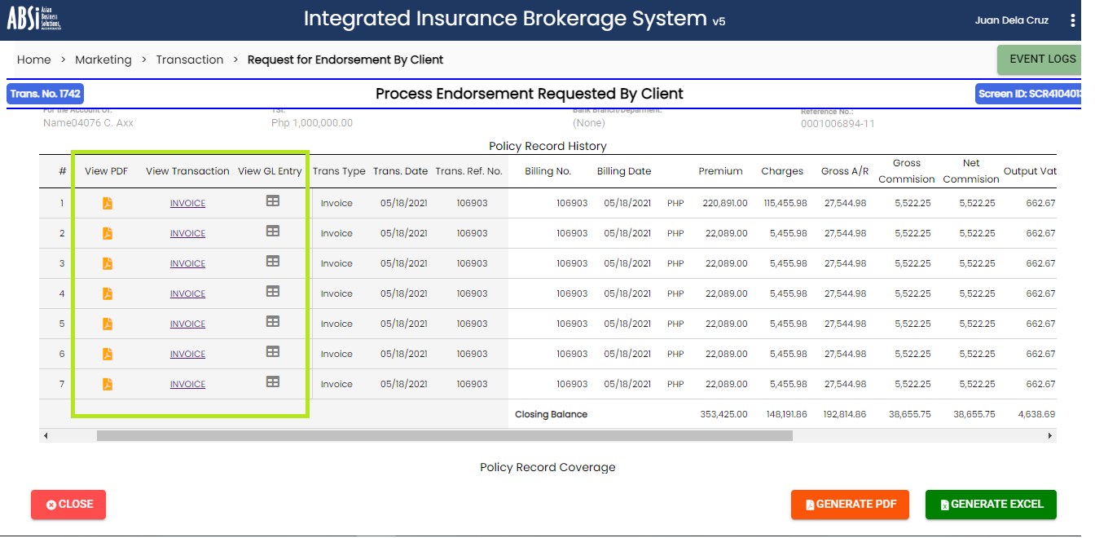

Second Screen

1. **DOCUMENTATION OVERVIEW**

This guide describes the screen functionalities of the Endorsement transaction. It contains

(1) breadcrumb information how to navigate to the screen, (2) navigation and workflow

steps, (3) common controls for tracker, navigation buttons, and summary information, and

(4) usage information for the basic functions of screen objects and web components,

together with their corresponding definition.

1. **SCREENS AND REPORTS LIST**

* SCREEN/REPORT ID - SCR4104013
* SCREEN/REPORT NAME - Endorsement – Policy Transaction History
* DESCRIPTION - - Screen to show the policy record history and the policy record coverage to serve as a reference and guide to the end-user.

1. **SCREEN DESIGN SPECIFICATIONS**

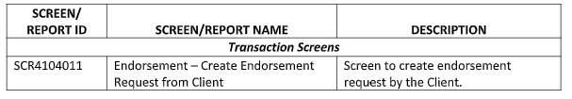

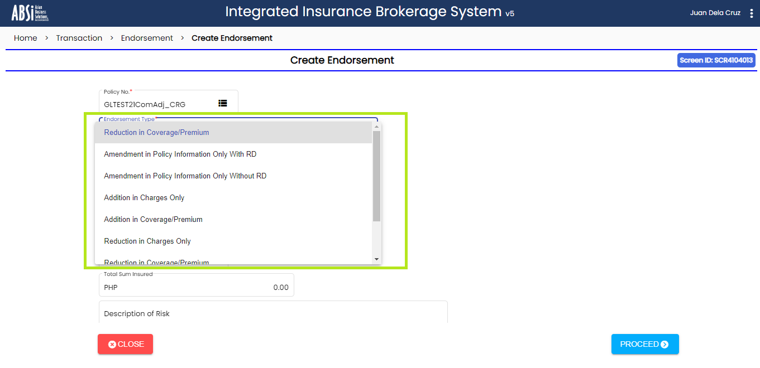

System will determine the next step based on the endorsement type

selected. The following are the endorsement type:

* Amendment in Policy Information without RD - This option will route the work item for Encoding of Amendment Without RD
* Amendment In Policy Information with RD - This option will route the work item for Encoding of Amendment With RD
* Inclusion in Charges Only - This option will route the work item for Encoding of Inclusion in Charges
* Inclusion in Coverage Premium - This option will route the work item for Encoding of Inclusion in Coverage Premium
* Reduction in Charges Only - This option will route the work item for Encoding of Reduction in Charges
* Reduction in Coverage Premium - This option will route the work item for Encoding of Reduction in Coverage Premium
* Pro-Rata Cancellation - This option will route the work item for Encoding of Pro-Rata Cancellation
* Flat Cancellation - This option will route the work item for Encoding of Flat Cancellation

The function of selection based on user’s selected value was not working, it works only when using “select and option tag”.

* 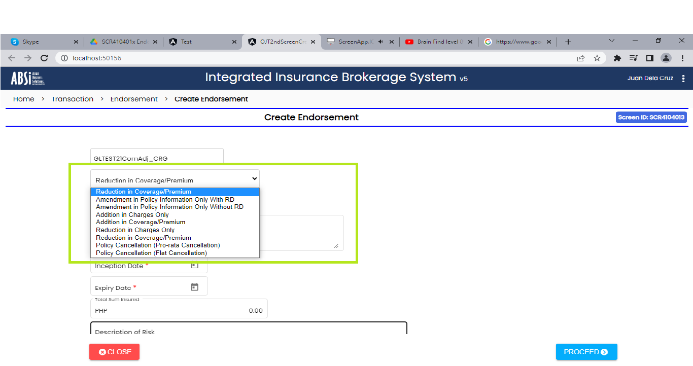
* 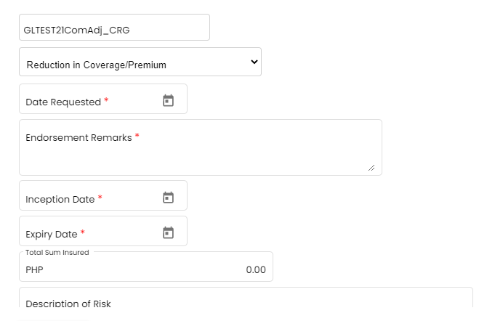

1. When user selected Amendment in Policy Information without RD, Addition in Coverage/Premium and Reduction in Coverage/Premium it will display all fields such as:

* Date Requested
* Endorsement Remarks
* Inception Date
* Expiry Date
* Total Sum Insured
* Description of Risk
* Location of Risk

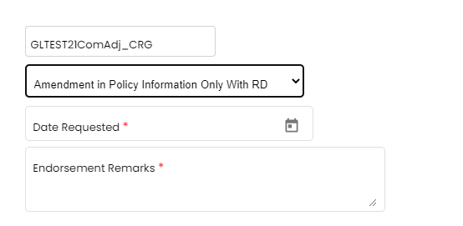

1. When user selected Amendment in Policy Information only with RD, Amendment in Policy Information only without RD, Addition in Charges Only, Reduction in Charges Only and Policy Cancellation (Flat Cancellation) it will display two fields such as:

* Date Requested
* Endorsement Remarks

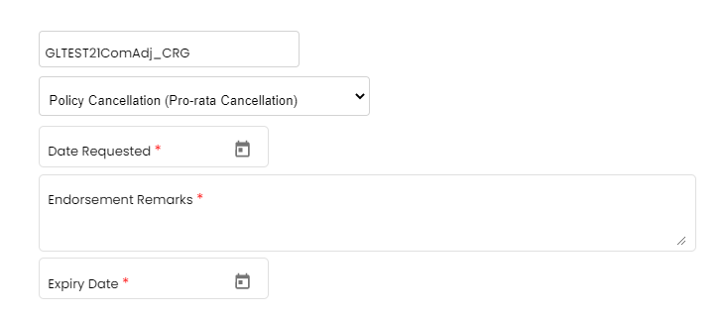

1. When user selected Policy Cancellation (Pro-rata Cancellation) it will display three fields such as:

* Date Requested
* Endorsement Remarks
* Expiry Date

NOTE: The Date Picker Input is disabled the input to avoid entering word or other invalid keywords. The Text Area Input height contains three-line words visible. All Disable forms has no outline in their forms. Input that has selection icon is disabled to select only the List-of-Data.

Third Screen

**Request for Documentation Panel**

Allowing user to specify the Contact Person and choose whether to send RD by

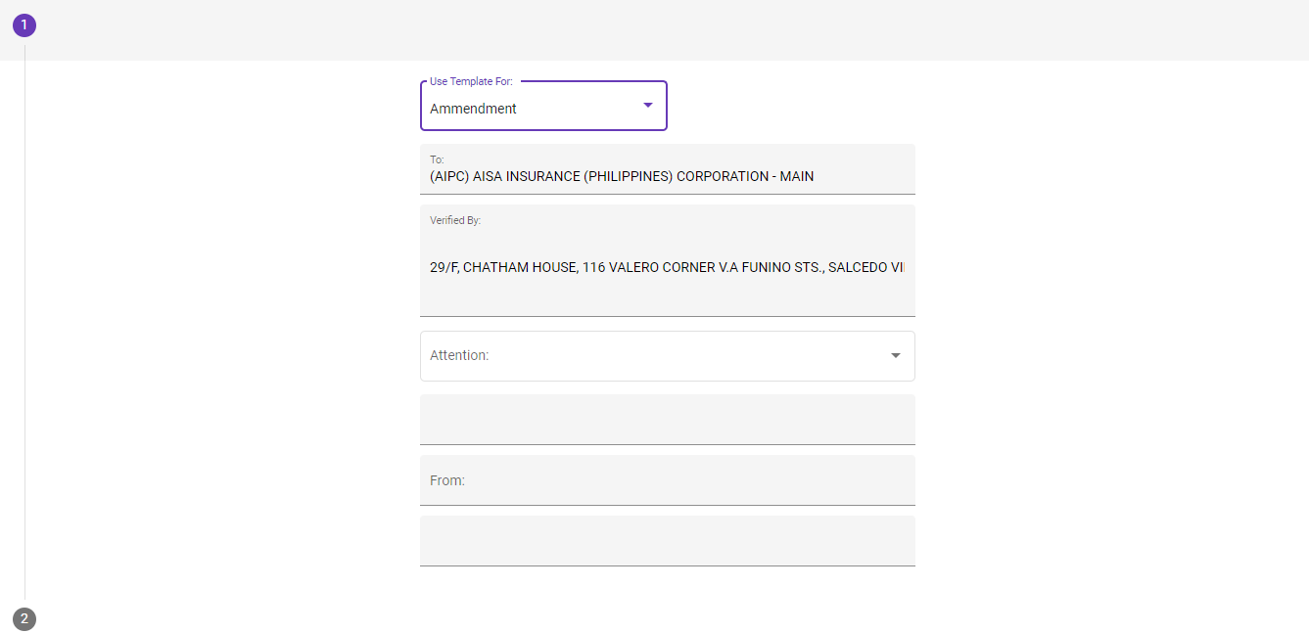

This is only the design of 3rd screen I finished. It includes fields such as:

* Use Template for and Attention (Select option)
* Input Fields